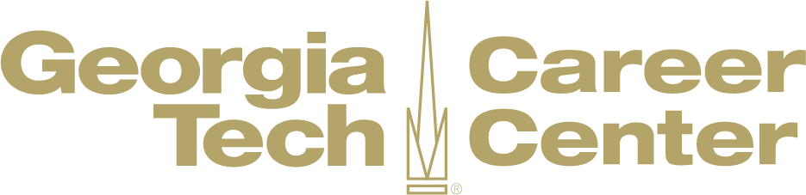

Virtual Career Fair Tips
No matter what type of event technology is used, here are some general tips from the Georgia Tech Graduate Career Education team to successfully navigate virtual career fairs .

Before the Fair
- Know who will be there. Review the list of registered companies and identify organizations you are most interested in pursuing. Do some research and explore the companies that interest you, focusing on mission, culture, and skills valued. Prepare a list of questions for each employer based
on your research of the organization. Consider the following examples of types of questions to ask.

- Know what you will say about yourself, your skills, and what you can bring to the company. Describe specific experiences where you demonstrated your strengths; examples will make you a stronger candidate. Practice this introduction with someone else, so that you get comfortable introducing yourself. Better yet – practice this virtually during a Zoom call with a friend!

- Prepare your resume. Update your resume, and make sure that it highlights your most marketable skills. Employers have the option to collect resumes through an the online resume book, so we recommend that you save your resume as a PDF to ensure a smoother upload. Also, make sure to have multiple versions (if needed) based on the different organizations/positions you anticipate engaging with during the fair. You can always make an appointment with a graduate career advisor to review your resume.

- Prepare your space. For virtual fairs, you will want to make sure your technology is functioning properly. Test your internet reception, webcam, and microphone quality. Also, make sure to have backup options if technical glitches occur (i.e. a phone nearby if you need to call in). Because you may be able to interact with recruiters via video call, you should also make sure to find a clean, quiet, well-lit space. Make sure there any inappropriate posters or hidden or blurred, empty pizza boxes, dirty dishes, or anything you would not want a potential employer or recruiter to see in your home or your workspace.

At the Fair
- Dress to impress. Even at a virtual career fair there is the possibility of a video chat with an employer, so we recommend dressing the same way you would for an in-person fair. We encourage students to dress in "smart" casual or business casual attire. Examples include khakis, dress pants, skirts, button-down long sleeve shirts, sweater sets, blouses. Check out the Harvard Business Review and what they had to say about dress code for virtual interviews.

- Make sure you are ready. Your phone should be either off, on airplane mode, or silent. Any music should be off in the background (radio, phone, etc). Also, make sure you are in a quiet space where lawnmowers, pets, kids, or outside noises won’t be a distraction to you or the recruiter.

- Use good body language. In a virtual environment, body language and how you present yourself matters. Give a genuine smile when introducing yourself. Eye contact is very important to demonstrate interest and engagement. In a virtual environment, making eye contact means looking directly into the camera (not at yourself or the other person). This can take some getting used to, so practice with friends or family ahead of time. Sit up straight and avoid crossing your arms – you want to appear engaged and attentive. Also try to limit distracting behaviors like fidgeting, playing with your hair, looking around when talking or being spoken to, or chewing gum.

- Speak with confidence. It is important to speak slowly and clearly during a virtual conversation. Be sure not to talk over the other person – give them time to finish asking or answering a question before speaking. Answer questions confidently and definitively, just like you would at an in-person event.

- Be prepared to chat. Many virtual career fair platforms use chat functionality to allow employers and students to interact with each other. Just like any other communication with an employer, you want to keep these professional. Avoid using slang, emoticons, or acronyms (ex. LOL, UR) in your chats, and have questions prepared ahead of time for the employer so that you can quickly type them in. Take a look at our Professional Development Video Series if you need some help making “Small Talk”.

- Take notes. Be sure to have a notebook and pen next to your computer to jot down notes and contact information. It is important to not seem distracted or appear as if you are doing other things on your computer. Having your resume printed out next to you during a virtual career fair can help too!

- Get contact information. Be sure to write down the name and email address of company representatives that you talk to.

- Cast a wide net! The fair is a great chance to compare and contrast many opportunities in a relatively short time (and is much more efficient than attending a one-hour presentation by each participating organization!). Be sure to do your research ahead of time so that you understand what each company does, what kinds of opportunities they are hiring for, and be prepared to talk about why you might be a good fit.

After the Fair
- Follow up. Send a thank-you email along with your resume; use the opportunity to reiterate how your background and skills match their needs. Consider using LinkedIn to connect with the contacts you made.

- Reference someone you engaged with at the fair in the opening paragraph of your cover letter. For example, “After interacting with Jane Doe at the Diversity Opportunities Fair, I know my analytical and communication skills will be a good fit for the marketing Internship role at WGBH.” You do not need to know the contact extensively but be genuine in how you refer to him or her.

- Maintain contact. Companies are busy doing what they do and may not get back to you right away. It’s okay to send a reminder if you haven’t heard anything in a few days. Better yet, find an article based on what you discussed during the fair, or related to the organization’s industry, and send that along with your email. It shows that you are genuinely interested in their work and actually paid attention.

